EXPERIMENT- 09
Dilate an Image using Dilate Function
Aim
To write a Python code to perform image dilation using OpenCV for expanding object boundaries and filling small gaps in the image.
Input Image
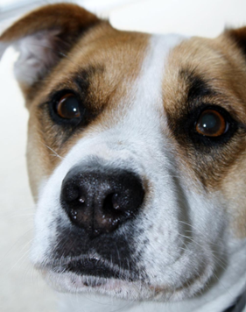
Code
import cv2
import numpy as np
from google.colab.patches import cv2_imshow
from google.colab import files
uploaded=files.upload()
image_path=list(uploaded.keys())[0]
image=cv2.imread(image_path,cv2.IMREAD_GRAYSCALE)
if image is None:
print("Error: Image not found")
else:
kernel=np.ones((5,5),np.uint8)
dilated_image=cv2.dilate(image,kernel,iterations=1)
print("Original Image")
cv2_imshow(image)
print("Dilated Image")
cv2_imshow(dilated_image)
Output Image
Dilated Image
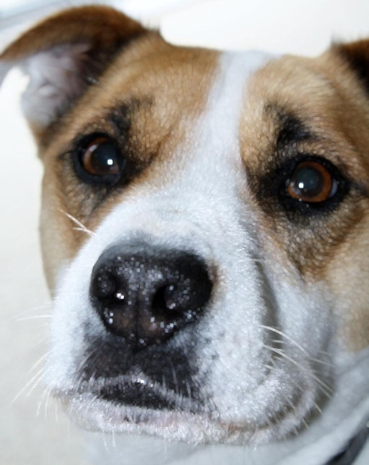
Result
Thus, the image was successfully dilated using OpenCV.

